Send me your work or any questions at ccs@tda.education
¡Hola chicos y chicas!
Write the date in Spanish on your book:

Hoy es___________, _____de______________del 2020

Following last week Reading, we are going to try to write something similar ( just the first paragrah this week)

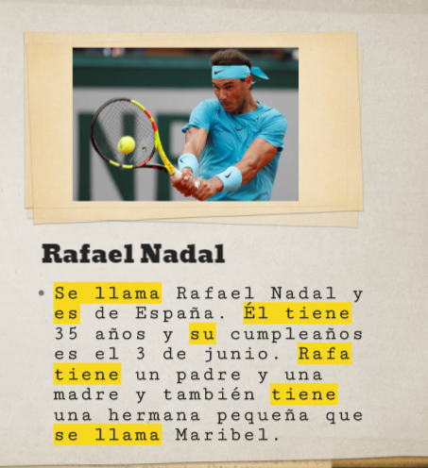
- We are writing in THIRD person ( about someone).
- The highlighted structures are VERBS in third person.
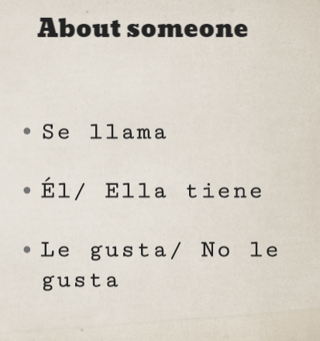
- The rest is information about Rafael Nadal

( he/ she is called)
He/She has got
He /she likes // He/ she doesn´t like

- Choose a famous person or a friend or a family member
- Following the structure of the paragraph above, write your own one ( about someone)
- Remeber that your text should include
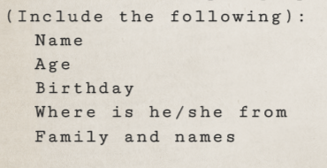
¡Buena suerte!

